ADITHYA R
192311369

9. Create a Snapshot of a VM and Test it by loading the Previous Version/Cloned VM using virtual
AIM: To create a snapshot of a virtual machine in VirtualBox and test it by restoring the previous version or using a cloned VM
PROCEDURE:
*Open VirtualBox and select the virtual machine you want to snapshot.
*Click Snapshots → Take Snapshot, give it a name and description, then click OK.
*Make changes in the VM (e.g., install software or modify files).
*To test, select the snapshot and click Restore to return the VM to the previous state.
*Optionally, clone the VM by right-clicking the VM → Clone, and test the cloned VM separately.

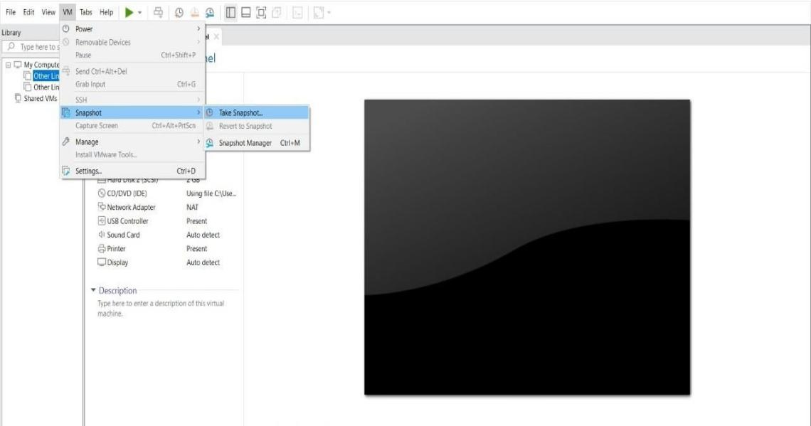
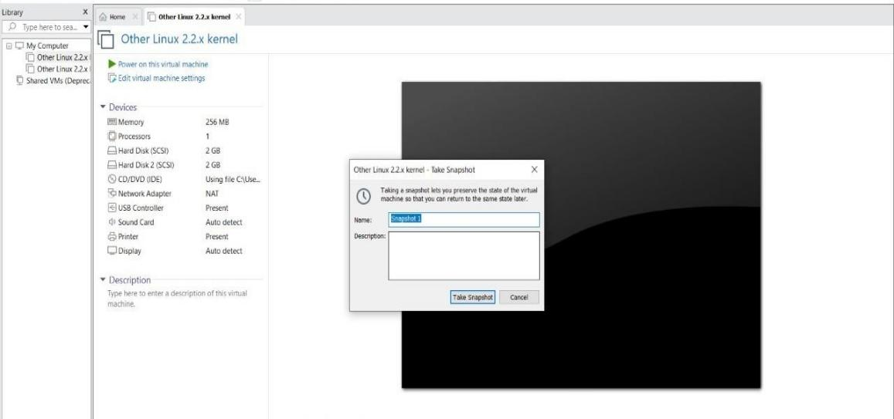
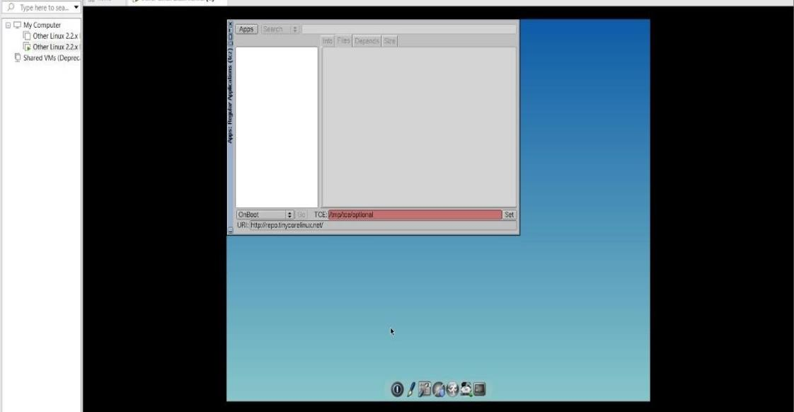

RESULT:
- A snapshot of the virtual machine is successfully created.
- Restoring the snapshot reverts the VM to its previous state, confirming the snapshot works correctly.
- The cloned VM runs independently with the same configuration, ensuring backup and testing are successful.

